**Chapter 3**

**Functions, Limit and Continuity**

* **Lecture Content:**
* 1.1 (Page 10): Basic Concepts on Functions.
* 1.1 (Page 15): The Vertical Line Test
* 1.1 (Page 15): Piecewise functions.
* 1.1 (Page 16): Absolute Value function.
* 1.1 (Page 16): Example 7 & 8.
* 1.1 (Page 17): Symmetry.
* Also discuss on skew-symmetry function.
* **Floor and Ceiling Function:**

Let $x$ be a real number.

The floor function of $x$, denoted by $\left\lfloor x\right\rfloor$, is the largest integer that is smaller than or equal to $x$.

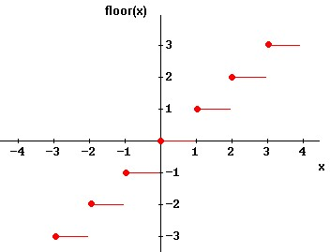

Example: $\left\lfloor 0.7\right\rfloor =0.$

The ceiling function of x, denoted by $\left\lceil x\right\rceil$, is the smallest integer that is larger than or equal to $x.$

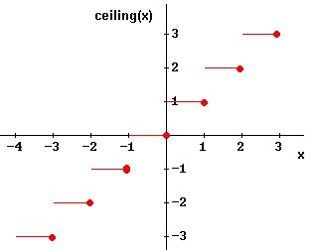

Example: $\left\lceil 0.3\right\rceil =1.$

* **Unit Step Function:**

$$f\left(t\right)=\left\{\begin{aligned}0;for t<0 \\ 1;for t>0\end{aligned}\right.$$

We do not define $f\left(t\right)$ at $t=0.$ Rather, at $t=0$ we think of it as in transition between $0$ and $1.$ It is called the unit step function because it takes a unit step at $t=0.$ It is sometimes called the Heaviside function.

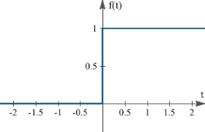

**Sample Exercise Set 3.1**

1. Find domain and range of the following functions:

(a) (b) (c) (g)

(h) (i)

2. Exercise 1.1: (Page 21) 41 and 43.

3. Exercise 1.1: (Page 22) 57, 61, 62 and 63.

* **Lecture Content:**
* 1.3 (Page 36-40): Transformation of Functions.

**Sample Exercise Set 3.2**

Sketch the graph of the following functions:

(a) $f\left(x\right)=x^{2}+2,$ (b) $f\left(x\right)=-{\left(x+2\right)}^{2}$ +2, (c) $f\left(x\right)=-x^{3}+2,$

(d) ${f\left(x\right)=\left(x-1\right)}^{3},$ (e) $f\left(x\right)=ln\left(x+1\right),$ (f) $f\left(x\right)=-e^{x+3}$,

(g) $f\left(x\right)=\frac{1}{x+2},$ (h) $f\left(x\right)=sin{2x},$ (i) $f\left(x\right)=-\cos{x,}$ (j) $f\left(x\right)=\left|x-2\right|+1,$

(k) $f\left(x\right)=\sqrt{2-x}+1,$ (l) $f\left(x\right)=\sinh{x}$ (m) $f\left(x\right)=\cosh{x.}$

* **Lecture Content:**
* 2.2 (Page 83): Limit of a function.
* 2.2 (Page 87): One sided limit.
* 2.2 (Page 88): Example 7.
* 2.2 (Page 90): Vertical Asymptote.

**Sample Exercise Set 3.4**

1. Sketch and find limit of the function at

1. Sketch and Find limit of the function at and

2. Sketch and find limit at $x=0$ and $x=π$ of

$$f\left(x\right)=\left\{\begin{aligned}1+\sin{x;x<0} \\ \cos{x;0≤x≤π} \\ \sin{x;x>π}\end{aligned}\right.$$

* **Lecture Content:**
* 2.3 (Page 95): Calculating limits using the limit laws.
* 2.3 (Page 97-101): Example 2- Example 10.

**Sample Exercise Set 3.5**

Exercise 2.3 (Page-103) 47 & 50.

* **Lecture Content:**
* 2.5 (Page 114-115): Continuity- just definition.
* 2.5 (Page 115): Example 2.

**Sample Exercise Set 3.6**

Exercise 2.5 (Page 124) 17 & 18.

Exercise 2.5 (Page 125) 39 & 40.

* **Lecture Content:** 
  + **Differentiability of a function:**

Let the function  be defined on an open interval *I* and . The function  is said to be differentiable at if

* 

exists, i.e., **left hand derivative**  is equal to **right hand derivative**  .

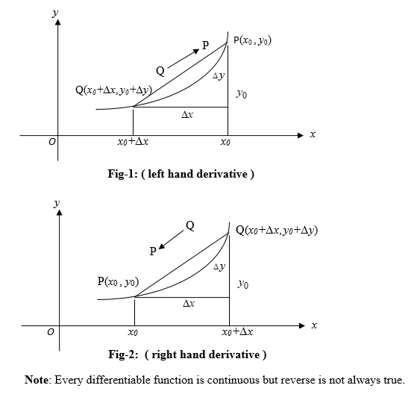

**Sample Exercise Set 3.7**

1. Sketch the following graphs and determine whether functions are differentiable at the indicated points:

(a) $y=|x-3|$ at $x=3$, (b) $f\left(x\right)=\left\{\begin{aligned}2x^{2}, x≤1 \\ 4x-2, x>1\end{aligned}\right.$, at $x=1$,

(c) 

* **Lecture Content:**
* **Basic formula and rules of differentiation.**

**Sample Exercise Set 3.8**

1. Using 1st principal of differentiation find and

2. Find from the following functions:

(a) $y=\sin^{2}{x}$ (b) $y=\cos^{2}{x}$ (c) $y=\tan^{2}{x}$ (d) $y=\frac{\sin{x}}{x}$ (e) $y=\frac{\tan{x}}{\ln{x}}$ (f) $y=x^{2}\sin{x}$

(g) $y=\cos^{3}{x\ln{x}}$ (h) $y=\sin\left(x^{2}\right)$ (i) ${\left(2x+1\right)}^{2}$ (j) ${\left(\sin{x}\cos{x}\right)}^{3}$ (k) $\ln\left(\sin\left(x^{2}+1\right)\right)$

(l) $x^{x}$ (m) ${Sin x}^{\tan{x}}.$